**AIR QUALITY MONITOR**

INTRODUCTION:

The air quality monitor which can measure surrounding air quality also shows temperature and humidity in your room or other public places .

COMPONENTS:

1.DHT11 Temperature & Humidity Sensor (3pins)

2.0.96" i2c OLED display

3.Arduino Nano R3

4.Air Quality sensor (MQ135)

TOOLS:

1. 3D printer
2. Soldering iron.

APPS AND PLATFORMS:

[ Arduino IDE ]

CIRCUIT DIAGRAM:

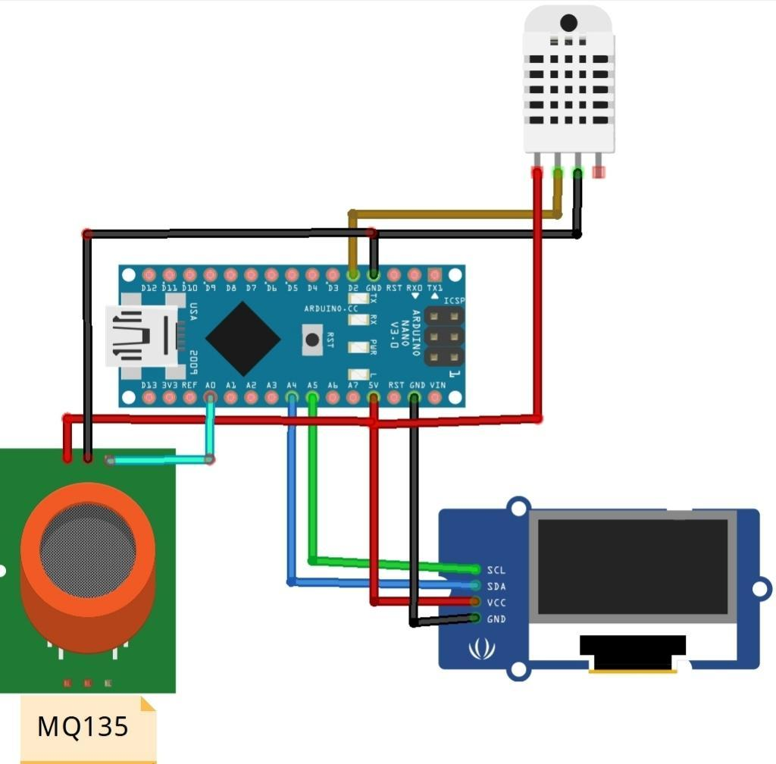

PROJECT DESCRIPTION:

Many times we feel very weak while waking up from the bed even after getting a good sleep at night. This sometimes happens because of the poor air quality in the closed room at night but these can solved by using Arduino device.

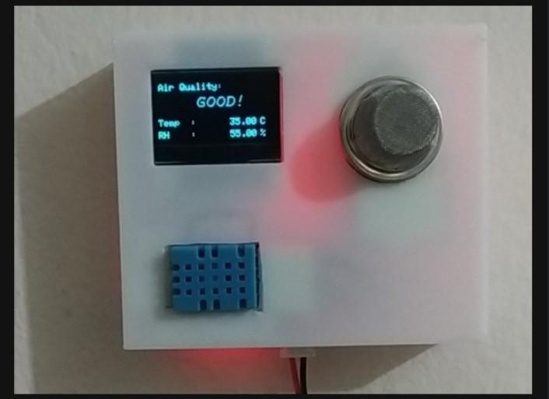

This is a low cost Air Quality Monitor which can monitor the air quality of a room using MQ135 air quality sensor. It also measure the room temperature and humidity using DHT11 and shows the data on a OLED display. It is a fun little project and very helpful too.

CONNECTION:

* Arduino D2 to DHT11 out
* Arduino A0 to MQ135 Ao
* Arduino A5 to Oled SCL
* Arduino A4 to Oled SDA

PROGRAM:

(In the coding part you will need to install some library to run the code

Adafruit_SSD1306.h

Adafruit_GFX.h

DHT.h )

**#include <SPI.h>**

**#include <Wire.h>**

**#include <Adafruit_GFX.h>**

**#include <Adafruit_SSD1306.h>**

**#include <Fonts/FreeSans9pt7b.h>**

**#include <Fonts/FreeMonoOblique9pt7b.h>**

**#include <DHT.h>**

**#define SCREEN_WIDTH 128 // OLED display width, in pixels**

**#define SCREEN_HEIGHT 64 // OLED display height, in pixels**

**#define OLED_RESET 4 // Reset pin # (or -1 if sharing Arduino reset pin)**

**Adafruit_SSD1306 display(SCREEN_WIDTH, SCREEN_HEIGHT, &Wire, OLED_RESET);**

**#define sensor A0**

**#define DHTPIN 2 // Digital pin 2**

**#define DHTTYPE DHT11 // DHT 11**

**int gasLevel = 0; //int variable for gas level**

**String quality ="";**

**DHT dht(DHTPIN, DHTTYPE);**

**void sendSensor()**

**{**

**float h = dht.readHumidity();**

**float t = dht.readTemperature();**

**if (isnan(h) || isnan(t)) {**

**Serial.println("Failed to read from DHT sensor!");**

**return;**

**}**

**display.setTextColor(WHITE);**

**display.setTextSize(1);**

**display.setFont();**

**display.setCursor(0, 43);**

**display.println("Temp :");**

**display.setCursor(80, 43);**

**display.println(t);**

**display.setCursor(114, 43);**

**display.println("C");**

**display.setCursor(0, 56);**

**display.println("RH :");**

**display.setCursor(80, 56);**

**display.println(h);**

**display.setCursor(114, 56);**

**display.println("%");**

**}**

**void air_sensor()**

**{**

**gasLevel = analogRead(sensor);**

**if(gasLevel<181){**

**quality = " GOOD!";**

**}**

**else if (gasLevel >181 && gasLevel<225){**

**quality = " Poor!";**

**}**

**else if (gasLevel >225 && gasLevel<300){**

**quality = "Very bad!";**

**}**

**else if (gasLevel >300 && gasLevel<350){**

**quality = "ur dead!";**

**}**

**else{**

**quality = " Toxic";**

**}**

**display.setTextColor(WHITE);**

**display.setTextSize(1);**

**display.setCursor(1,5);**

**display.setFont();**

**display.println("Air Quality:");**

**display.setTextSize(1);**

**display.setCursor(20,23);**

**display.setFont(&FreeMonoOblique9pt7b);**

**display.println(quality);**

**}**

**void setup() {**

**Serial.begin(9600);**

**pinMode(sensor,INPUT);**

**dht.begin();**

**if(!display.begin(SSD1306_SWITCHCAPVCC, 0x3c)) { // Address 0x3D for 128x64**

**Serial.println(F("SSD1306 allocation failed"));**

**}**

**display.clearDisplay();**

**display.setTextColor(WHITE);**

**display.setTextSize(2);**

**display.setCursor(50, 0);**

**display.println("Air");**

**display.setTextSize(1);**

**display.setCursor(23, 20);**

**display.println("Qulaity monitor");**

**display.display();**

**delay(1200);**

**display.clearDisplay();**

**display.setTextS**

Working of Air Quality monitor system using Arduino:

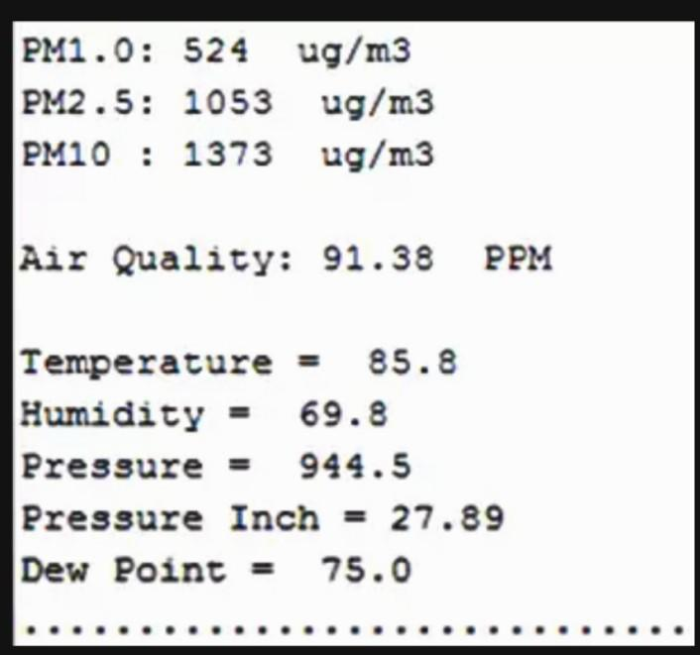

CONCLUSION :

Here the Quality of air is indicated in Parts Per Million (PPM) Units where lower the number of PPM indicates the good quality of air and higher the number indicates the polluted air with toxic gases which can cause health issues.